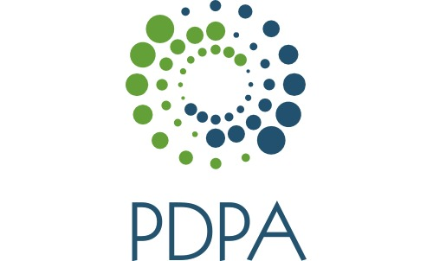

Pennsylvania Dermatology Physician Assistants

Invites you to attend an educational program entitled

[Title]

Speaker: [Name}
Learning Objectives: At the conclusion of this presentation, the learner will be able to

1. (objective)
2. (objective)
3. (objective)

Location: [Name]

Date: [ ]

Time: [ ]

RSVP 2 weeks prior to the event by registering online at padermpa.org under the event

This program has been reviewed and is approved for a maximum of one hour of AAPA clinical Category I (Preapproved) CME credit by the Physician Assistant Review Panel. Physician assistants should claim only those hours actually spent participating in the CME activity.

This program was planned in accordance with AAPA’s CME standards for Live Programs and for Commercial support of Live Programs.

This program was supported by an educational grant from PDPA.

