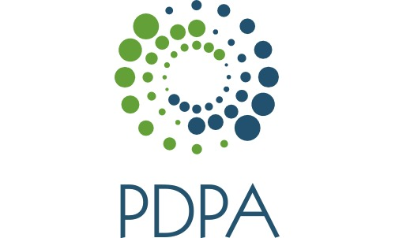
CME Evaluation: Lecture-Learner Programs
Sections 1-3 to be completed by CME chair.
Section 4 to be completed by each participant.

1) Program Information
Name of Program: __________________________________________________________________________________
Date: _____________________________________ Time: _________________
Location: ________________________________ Length of presentation: 1 hour

2) Grantor Information
Name of corporation: Pennsylvania Dermatology Physician Assistants

3) Speaker Information
Name: _________________________________________________________________________________________

4a) Objectivity (NOTE: If NOT industry sponsored, please skip section 4a and indicate here by circling N/A and proceed to section 4b
Yes No

Are you aware of drugs/ products related
to topic that are produced by the grantor? 5 4 3 2 1

Did speaker present a balanced view
of therapeutic options? 5 4 3 2 1

Did you detect bias in favor of the products
produced by the grantor? 5 4 3 2 1

Were brand name(s) mentioned
during presentation? Yes No
If yes, which ones? _________________________________________________________________________________

Did the speaker discuss unlabeled uses of
any products? Yes No

If so, was it disclosed that they were
unlabeled uses? Yes No

Were relationships between grantor and
speaker (e.g., payment of honorarium)
announced prior to presentation? Yes No

4b) Objectivity
Please rate the following: Outstanding Poor
- Program content. 5 4 3 2 1
- Relevancy of content to your practice. 5 4 3 2 1
- Were explicit learning objectives stated? 5 4 3 2 1
- Were learning objectives met? 5 4 3 2 1
- Please rate the program overall. 5 4 3 2 1
- As a result of this program, will you alter your practice? Yes No Maybe

Comments:

